User Documentation

Conient {an i-scream client}

Conient is a Java-based client for use with the i-scream Distributed Central Monitoring System. This document provides a guide to using Conient on your desktop system to provide you with real-time graphical display of the data currently passing through the i-scream system.

Revision History

12/03/01 | Initial creation
 |  | Committed by: | ajm4 | Verified by: | tdb1  pjm2
 |  |  |  | Date: | 25/03/01
 |  | Committed by: |  | Verified by:
 |  |  |  | Date:
 |  | Committed by: |  | Verified by:
 |  |  |  | Date:
 |  | Committed by: |  | Verified by:
 |  |  |  | Date:
 |  | Committed by: |  | Verified by:
 |  |  |  | Date:

Introduction 2
What is Conient? 3
How can I get Conient? 3
How do I start Conient? 3
What are the main features of the display? 4
How can I quickly get Conient displaying data? 5
Basic Configuration 5
The Control Link 5
The Data Link 6
How do I navigate Conient’s data display? 6
What options does Conient have? 8
Client Options 9
Client Name 9
Known Hosts 9
Hosts To Monitor 9
Server Options 10
Automatically Connect 10
i-scream Server 10
Client Interface Port 10
Firewall Options 11
Firewall command 11
Firewall wait time 11
Firewall server 11
Data Options 12
Display server queue information 12
Display extra data found in packets 12
Dump raw packet data to the console 12
Maximum data queue size 12
How do I manage my Conient configurations? 13
The default configuration 13
Saving your configuration 13
What warnings and errors can occur? 13
Protocol Messages 13
Configuration Messages 13
Open Link Messages 14
Link Establishment Messages 14
Firewall Messages 14
Data Messages 14

Introduction

An i-scream client connects to the i-scream client interface and can obtain a hook to the flow of data currently passing through the system. This data is generated by host programs, which run on all the machines currently being monitored. They report a range of statistics about how a host is currently performing and pass that onto the i-scream server. Conient allows you to view this data.

What is Conient?

Conient is a remote client for the i-scream system, written to conform to version 1.1 of the i-scream client protocol. Conient allows you to either view all the data being sent through the system, or just data for specific hosts. It displays this data in a range of formats depending on the data, and can give you an idea of how a machine is currently performing.

How can I get Conient?
The latest build of Conient may be downloaded from the Builds section of the i-scream project website: -

http://www.i-scream.org.uk/builds/

The website also contains other information that you may find useful in setting up an i-scream monitoring system.

How do I start Conient?

Running Conient is usually a fairly straightforward task. Once you have downloaded the archive from the URL above, simply extract it to a directory, and then execute either “run.sh” for a Unix-based system or “run.bat” for a Windows system.

This will start up Conient, and after a few seconds you should see a splash screen indicating that Conient is starting. A few seconds later the main window should open with a blank display similar to that in Figure 1.

Note: Conient requires a java runtime environment that is compatible with at least v1.3 of the Java 2 Platform. To obtain a java runtime environment, please visit:

http://java.sun.com

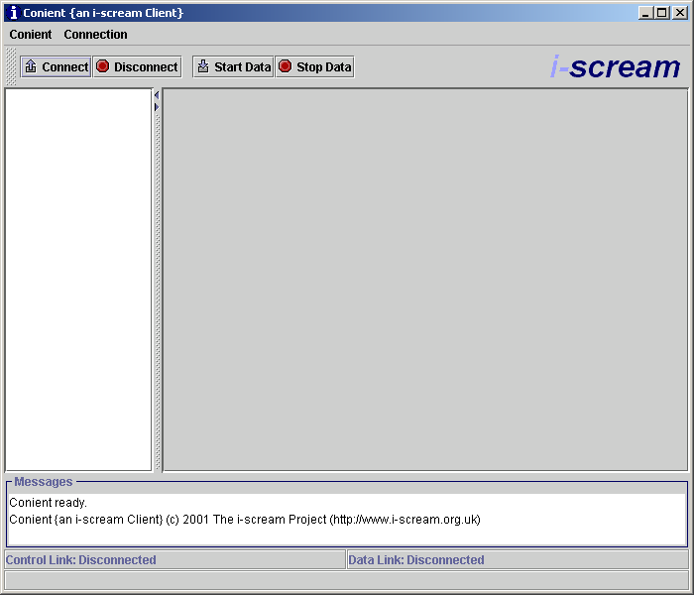
Figure 1

What are the main features of the display?

Starting at the top and working down, the first major feature (aside from the menus) is the toolbar (as shown in Figure 2). This has buttons allowing you to connect and disconnect from the server. “Connect” and “Disconnect” control the main client control link to the server. The “Start Data” and “Stop Data” controls the data link, and effectively instructs the server to start and stop sending data to the client.

Figure 2

The “messages” section (as shown in Figure 3) allows the Client to inform you of what it is doing, including any errors or warnings that have occurred. For information about what kind of messages may appear in this window. See the later section titled “What warnings and errors can occur?”.

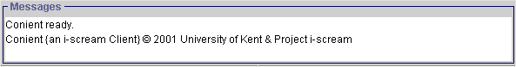
Figure 3

At the bottom of the display is the status panel (as shown in Figure 4). This panel provides information about the status of the two links to the server in the top half, and queue information about how much data is being processed by Conient in the bottom half. This queue information is only visible once a data link has been established.

Figure 4

How can I quickly get Conient displaying data?
In this section we will provide you with a quick start guide to getting Conient running, and explain the display that Conient provides.

Basic Configuration

First, you must tell Conient where the client interface is of the i-scream server you are running. To do this you should click on the “Conient” drop-down menu, then choose “Modify Configuration”. In this section we won’t go into detail about the various configuration options, for more information on them, see “What options does Conient have?” and “How do I manage my Conient configurations?”. A configuration window will then pop up with a set of tabs, select “Server Options”. The screen shown in Figure 5 should be displayed.

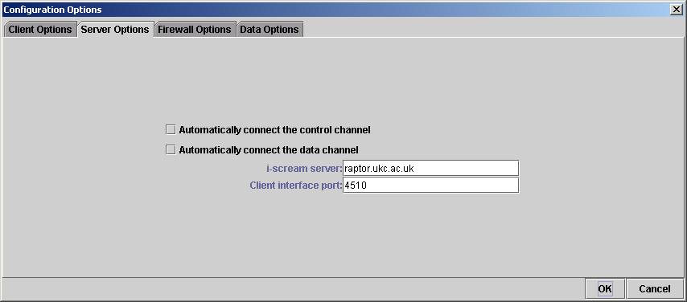
Figure 5
In the box labelled “i-scream server”, enter the fully qualified domain name or IP address of the machine that is running the i-scream client interface. In the “Client interface port” box enter the port number that the client interface is running on. To find this out, you will need to look in the main configuration file for the server. The standard port number is “4510”, so if you have not altered the servers configuration then you should use this. Once you have entered these details, click “OK” to apply the settings to Conient.

The Control Link

The next step is to establish the control link with the i-scream server. The control link allows Conient to talk to the i-scream server and issue a variety of commands that can control the data link. It is also used to obtain any configuration from the server to adjust how Conient displays its data.

To establish a control link simply click “Connect” on the tool bar, or choose the “Connection” menu and select “Connect” from there. The connection status for the control link should then change to “Connecting to - <i-scream server name>”, you will then receive notices in the Messages window confirming information as Conient handshakes with the i-scream. The lower half of the display should look like that in Figure 6.

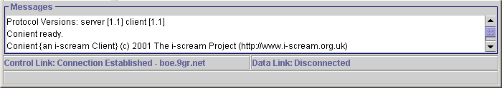
Figure 6
If you have any problems establishing a connection, please refer to the section later section titled “What warnings and errors can occur?”.

The Data Link

Once a control link has been established, the next step is to ask the server to open a data link port and then get Conient to connect to it. Conient handles this negotiation and opens the data link automatically. To tell Conient to do this, either click “Start Data” on the toolbar or “Start Data” from the “Connection” menu.

Conient will then start receiving data from the server. As each new host is detected, Conient obtains any configuration needed from the server and then adds the host display to the host list. Once all new hosts have been detected and all configurations have been displayed, Conient then simply updates the display for all the hosts as new data comes in.

How do I navigate Conient’s data display?

Once a control link and a data link have been established, the display is continuously updated as new packets of data for all the hosts are received. The main window should now look similar to that shown in Figure 7.
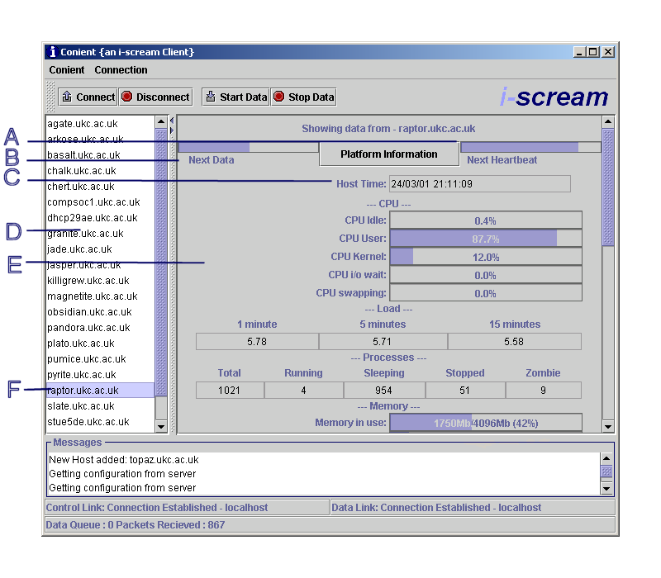
Figure 7
As you can see from the display a range of new items have been added. What follows is a description of all the highlighted parts of Figure 7.

- This is the heartbeat timer. A host sends a heartbeat to the i-scream server periodically (the default is every 60 seconds) to indicate that it is still alive. This bar counts down to indicate when the next heartbeat is expected. Note that this is just an indicator, and does NOT provide guarantees that a heartbeat will appear. A heartbeat packet from a host also contains service check data. When a host heartbeats, the i-scream server connects back to the host on certain ports to ensure system services such as HTTP are running. This information is encapsulated in a heartbeat packet; Conient can then display the results of the services checks in the main display area.
- This is the data timer. This timer counts down to indicate when the next packet of data is due to be received from a host. When the data is received, it is decoded and displayed. Note again though that it is simply an indicator to inform you of how stale the data in the display is.
- This is the time the data on display was generated on the host. This is relative to the host’s time zone and NOT the machine Conient is running on. This also gives an indication of how stale the displayed data is.
- This list contains an alphabetical list of hostnames that Conient is currently displaying data for. To view a particular hosts data, simply single click its name.
- This is the main data display area. Here all data received is displayed. Some data items have custom display methods (such as percentage bar), others are simply text components. You can use the scrollbar at the side to view all the data. Conient is configured to display a standard set of data items that are expected from a host. If a host does not send the data (e.g. a Windows host cannot send a Load value), then that data display simply remains hidden. It is envisaged that some hosts may send new types of data before Conient is updated to display them, thus Conient has support for displaying all the data it doesn’t know about as “Extra Data”. To find out more information about this and other configurable options, please see the section titled “What options does Conient have?”.
- This is the host that is currently being displayed.

You will also notice a button labelled “Platform Information”. Clicking this will produce a window similar to that in Figure 8.

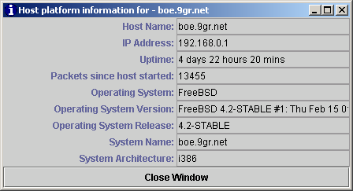
Figure 8
This displays information about the host’s operating system as well as other miscellaneous items. On Windows machines this will also show its NetBIOS network name.

What options does Conient have?

Conient has a variety of user configurable options. In this section we will go through each option that can be found under then “Modify Configuration” option under the “Conient” menu. For information on managing various Conient configurations, see the section titled “How do I manage my Conient configurations?”.

Client Options
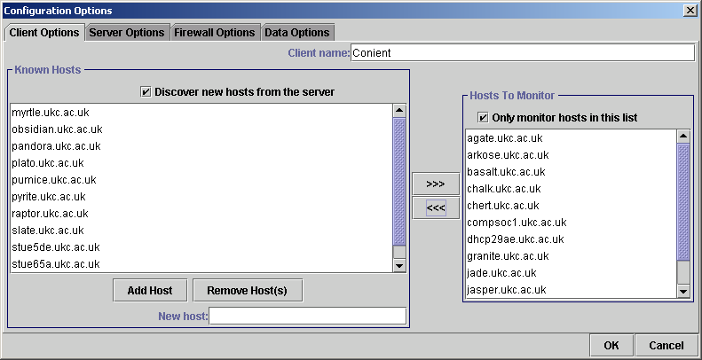
Figure 9

Figure 9 shows the Client Options panel.

Client Name
This name identifies this instance of Conient to the i-scream server. This is typically used for logging purposes. It is recommended that you use an identifier to yourself for this, making it easy to track users of Conient, but this is not enforced, e.g. “Conient-ajm4”. This name may also be used in future versions of Conient to obtain configuration options from the server, however this feature is not used in the present version.

Known Hosts
When Conient runs, it will be useful to make a permanent list of the hosts that the i-scream server is monitoring. By turning on the “discovery” mode, when a new host is detected sending data, its name is recorded in the “known hosts” list. You can use the box at the bottom of the list to add and remove host names from this list.

Hosts To Monitor
It may sometimes be desirable not to monitor all the hosts an i-scream server is receiving data for, but only a subset of those hosts. The “Hosts To Monitor” list allows you to select hosts from the “Known Hosts” list and add them. You can then set the option to “Only monitor hosts in this list”. When Conient next starts its data link, it will then ask the server to only send data from the hosts in this list. This is particularly advantageous when there are a large number of hosts being monitored, as it can greatly speed up Conient’s display of data, especially over a slow link.

Server Options
Figure 10
Figure 10 shows the Server Options panel.

Automatically Connect
The auto-connect feature allows Conient to start either one or both of the communication channels when it first starts up.

i-scream Server
This is the fully qualified domain name or IP address that the i-scream server’s client interface is running on.

Client Interface Port
This is the port number that the i-scream server’s client interface is running on. The default is 4510, but you should check with the i-scream server’s client interface configuration to confirm this.

Firewall Options
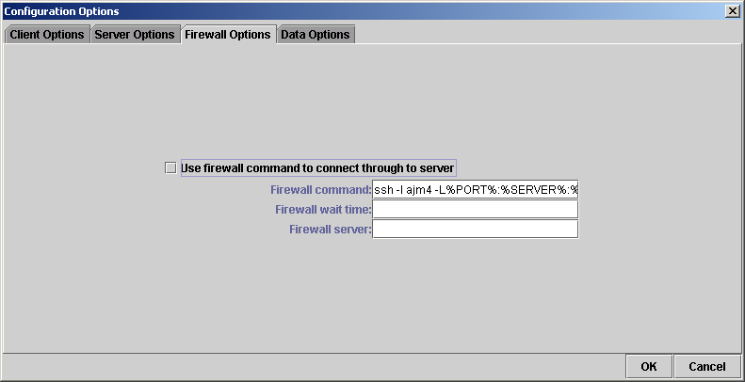
Figure 11
Figure 11 shows the Firewall Options panel.

Conient has limited support for being able to connect in through a firewall. It does this by allowing you to start a third party tunnelling tool. It then uses the ports opened by this tool to connect to the i-scream server.

Note: when the firewall options are in use, Conient networking may behave erratically as it cannot determine if the line is established well or not. The firewalling options are provided as an extra and are not supported.

Firewall command
This is the command that should be executed to open the tunnel. It uses two variables that are replaced by Conient. The %SERVER% variable should appear where the name of the machine to tunnel to would normally be on the command line. The %PORT% should appear where the port to tunnel to would normally be on the command line. Conient then executes this command, replacing these values, whenever a connection to an i-scream server is started.

Firewall wait time
This is the time in seconds that Conient should wait for the firewall command to complete setting up the tunnel. By default this is 5 seconds.

Firewall server
This is the machine to connect to that is running the tunnelling software. This allows you to establish the tunnel on a remote machine. This defaults to “localhost”, as it is assumed that you will normally be executing the firewall command locally.

Data Options
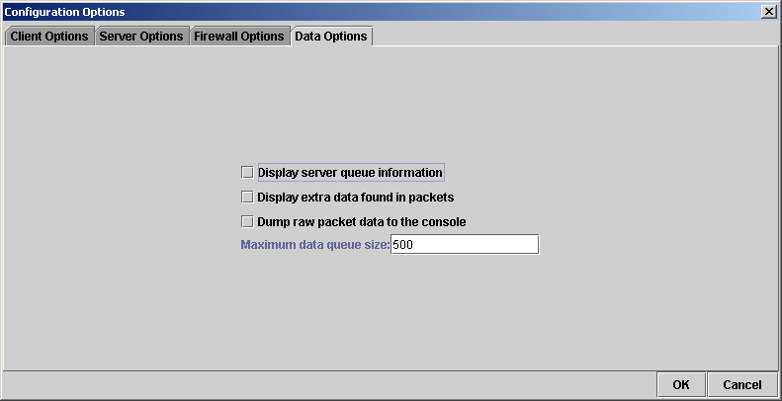
Figure 12
Figure 12 shows the Firewall Options panel.

This option pane allows you to configure some debugging features of i-scream.

Display server queue information
This opens when the data link is established. This window displays information obtained from all the internal queuing mechanisms within the i-scream server. This allows you to ensure that there is no backlog of data building up and that the server is performing as expected.

Display extra data found in packets
It is envisaged that in the future, hosts may be written to send data that Conient does not yet understand. This option allows this new data to be displayed if a host sends it, regardless of whether Conient is expecting it.

Dump raw packet data to the console
If a host appears to be sending odd information, and strange errors are appearing in the Messages box at the bottom of the display, then this option can be turned on. It simply dumps the raw data packets to the system console. This is useful for debugging the host, as well as ensuring data is passing through the i-scream system correctly.

Maximum data queue size
When data arrives into Conient, it is added to a data queue. Items from this queue are then processed and the display is updated accordingly. When Conient first gets information about a host, it has to ask the server for that host’s configuration options. This process can often be quite lengthy (especially on a slow link), and so this data queue may fill up quite quickly. Because the data for a host is updated every ten seconds, it is quite possible that some of this queued data could be out of date by the time it comes to being processed. That is why a limit on the maximum number of data items in the queue can be set. The default is 500 items. Once this limit is exceeded, the queue operates a first in first out basis for keeping the queue at this level. This effectively means old data is dropped as new data arrives. This option is used to configure this maximum queue size.

How do I manage my Conient configurations?

It is envisaged that you may require several configurations for Conient, and that you may wish to switch to different configurations with ease. To enable this Conient has support for saving and loading different configurations. All the configuration loading and saving options appear under the “Conient” menu.

The default configuration
This is typically loaded from the file “default.conf” under the “etc” directory where Conient is stored. However you can tell Conient to load a different configuration file as the default. This can be specified on the command line as follows:

“java -jar iscream-conient.jar <full path to default configuration>”

Note: if Conient fails to load the default configuration, it will display an error message indicating what the problem was and will then exit. Conient cannot be started without a valid default configuration present.

Saving your configuration
Under the Conient menu there are options to save the current configuration. Any changes (including the known hosts list) will only be saved if you use these options. You can choose to either save to a specific filename or to overwrite the default configuration.

Any file operations result in the displaying of a file chooser box which allows you to select the configuration to save and load. The standard extension for Conient configurations is “.conf”.

A message will appear informing of you as the result of the operation, i.e. whether it succeeded or failed.

What warnings and errors can occur?

The following are a few errors and warnings that may be displayed in the messages window, together with a description of what they mean.

Protocol Messages

WARNING{control link}: server is using a newer protocol
ERROR{control link}: incompatible protocol version

These messages are typically seen when Conient tries to talk to a server with a different i-scream client interface protocol. The protocol is defined to be backwards compatible, so if the server is using a newer version of the protocol, Conient will only warn you. If the server is using an older version of the protocol, then Conient will terminate the link as some of its features may not be available.

Configuration Messages

ERROR{control link}: client name rejected
WARNING{control link}: your host list is empty, the server will send ALL hosts
ERROR{control link}: no valid i-scream server port in current configuration

These messages are typically seen when there is a problem with your local configuration. Typically a configuration error will result in the termination of the links. However if there is a problem with your host list, Conient will just default to asking the server for ALL hosts.

Open Link Messages

ERROR{data link}: server unable to start data link at this time
ERROR{data link}: invalid data port suggested by server
WARNING{data link}: data reader thread did not close within timeout, killing its IO anyway!
ERROR{data link}: server didn't OK request to stop data channel - stopping anyway
CRITICAL{control link}: unable to close socket
ERROR{data link}: server reported error establishing data channel
WARNING{control link}: unable to set host list
ERROR{configuration}: server reported error when finishing configuration
ERROR{control link}: when setting host list - server refused - data link possibly still open?
WARNING{data reader}: inbound data stopped - unexpected loss of connection to server

These are typically seen when there is a problem with an established link. Warning messages normally indicate a problem has occurred, but Conient has dealt with it. Error messages normally indicate something went wrong on the link, and the connection will normally be terminated. Critical messages indicate an unrecoverable error has occurred. If after these errors are seen, Conient appears to behave erratically, it is recommended that you close and restart Conient.

Link Establishment Messages

WARNING{data link}: control link not established - queuing start events
WARNING{data link}: already established
WARNING{control link}: already established
WARNING{control link}: already disconnected
WARNING{data link}: already disconnected
WARNING{control link}: data link not disconnected - queuing stop events
WARNING: open connections detected - queuing stop events

These messages are simply warnings to indicate that a link is established and will be closed, or that it is already established when you say “Connect” or already closed when you say “Disconnect”.

Firewall Messages

WARNING{firewall}: firewall pipes requested, running pipe setup command
WARNING{firewall}: waiting 5 seconds for command to complete!
WARNING{firewall}: firewall process destroyed
ERROR{firewall}: unable to start pipe to i-scream server

The warning messages are seen when the firewall options are in use, and indicate what Conient is doing with regard to the firewall support. The error will be seen when there is a problem executing the firewall command.

Data Messages

WARNING{data panel}: <hostname> sent an invalid data or heartbeat packet
WARNING{data panel}: server sent data for an unexpected host - <hostname>
WARNING{data panel}: and unknown packet type was received - <packet type>
WARNING{host display}: <data> is an invalid data type for <component>

These warnings are seen when invalid data is received from the server. They provide information that may be useful for debugging. Often these errors occur because a host is sending invalid data, these messages will indicate both which host is causing the problem and which data item is erroneous. These errors are recoverable and Conient will simply skip processing that data item if they occur.

