User Documentation

i-scream Web Reports
The i-scream web reports provide an easy to access view of data from the i-scream monitoring system. This document provides instructions for setting up the Web Reports on a web server and an overview of how the reports may be used, both interactively and non-interactively.

Revision History

25/03/01 | Initial creation
 |  | Committed by: | pjm2 | Verified by:
 |  |  |  | Date:
 |  | Committed by: |  | Verified by:
 |  |  |  | Date:
 |  | Committed by: |  | Verified by:
 |  |  |  | Date:
 |  | Committed by: |  | Verified by:
 |  |  |  | Date:
 |  | Committed by: |  | Verified by:
 |  |  |  | Date:

Introduction 2
Real-time viewing 2
Historical reports 2
Alerts 2
Installation 3
Requirements 3
Obtaining the necessary files 3
Setting up the web reports 3
Configuring file locations 3
alerts_config.inc.php 3
browser_config.inc.php 3
latest_config.inc.php 4
public_config.inc.php 4
Setting up viewable information 5
Latest data reports 5
Using the report pages 5
Index 5
Latest reports 6
Historical reports 9
Alerts page 12
Setting up non-interactive public pages 15

Introduction
The i-scream web reports provide an easy to access view of data from the i-scream monitoring system. This document provides instructions for setting up the Web Reports on a web server and an overview of how the reports may be used, both interactively and non-interactively.

All reports are accessible via a web browser, thus enabling reports to be viewed potentially from anywhere in the world without the need for downloading specialist software.

The web reports provide an interface to viewing historical data collected by the i-scream monitoring system, as well as providing an almost real-time view of data and alerts from the system.

Real-time viewing
The web reports allow users to view the latest set of data received from each host. This is displayed in an easy to read manner, displaying values graphically where required.

Historical reports
The i-scream historical reports are typically generated each night. These may be viewed via the historical reports pages.

Alerts
The i-scream monitoring system can flag alerts for monitored hosts. Details of the latest alerts are always available from the alerts pages. The i-scream web alerts also provide a facility to construct a page suitable for displaying on a non-interactive public display screen, with automatic scrolling and updating via a web browser.

Installation

Requirements
The i-scream web reports are written in PHP and are known to work on any web server that has support for PHP4 scripting, including Apache. PHP is available for Microsoft Windows and Unix/Linux from: -

http://www.php.net

Obtaining the necessary files
All the files required for the installation of the i-scream web reports are available from the Builds section of the i-scream project website: -

http://www.i-scream.org.uk/builds

The website also contains other information that you may find useful in settings up an i-scream monitoring system.

Setting up the web reports
All of the files required for the web reports must be located in the same directory on the web server. The directory must be visible to browsers of the web server and support PHP4 scripts.

To determine whether PHP is correctly installed on your web server, you should attempt to access index.php from the web reports directory. If all is well, then you will see an index page with the i-scream reports logo at the top right.

Configuring file locations
It will be necessary to alter the config files for each section of the reports so that they know where to obtain the report data. There are 4 config files, each with the naming convention of {section name}_config.inc.php.

alerts_config.inc.php
This file is used for configuring the display of alert information. Before alerts can work, it is necessary to alter the value of $alertDirectory to the directory which contains the i-scream alert data. This data is generated by the server.

If your alert data is stored in the directory “/home/proj/co600_10/webroot/alert”, then you would set the following: -

$alertDirectory = "/home/proj/co600_10/webroot/alert";

browser_config.inc.php
This file is used for configuring the display of historical reports. Most settings in this file may be safely left alone, however, it will be necessary to alter at least the first two values in the file.

$reportDirectory is used to specify the location of the historical report data charts.
$webRoot is used to specify the location of the above directory on the web server.

It is important to note that the contents of the historical report data directory must also be visible via the web server. This is not necessary for other report types.

For example, if your historical report data is located in the directory “/home/cut/pjm2/webpages/reports/historical” and this directory is accessible via the web at “http://raptor.ukc.ac.uk/~pjm2/reports/historical/”, then you would set the following: -

$reportDirectory="/home/cut/pjm2/webpages/reports/historical";
$webRoot="/~pjm2/reports/historical";

The value of $maxDaysShown determines how many days will be displayed in the drop-down selection box for the day. This is set to 7, however, you may change this to another value (e.g. 10) like so: -

$maxDaysShown = 10;

This would result in the 10 most recent report days being shown in the drop-down box.

latest_config.inc.php
Many of the settings in this file may be altered to affect the look and feel of the latest data pages. However, it is only necessary to change two settings.

$latestDirectory and $latestData are used to specify the locations and filenames of the latest data files created by the i-scream monitoring system. For example, if the monitoring system is configured to store latest data in "/usr/local/proj/co600_10/webroot/latest" with file names of "latest_data" for each machine, then you would set the following: -

$latestDirectory = "/usr/local/proj/co600_10/webroot/latest";
$latestData = "latest_data";

public_config.inc.php
This file contains settings to configure the appearance of the public set-up page. All of these settings will work ‘out of the box,” so it is not essential to alter these.

Setting up viewable information

Latest data reports
The contents of the latest data pages are determined by the contents of the latest_display.inc.php file. This file uses showStat, showBar, showDisks and printLine functions to determine what data is presented, how it is presented, and how it is laid out. The default contents of the file are suitable for general use with any i-scream system, however, you may change these is it is required. We recommend that you read the i-scream web reports maintenance documentation for further details on how to achieve this.

Using the report pages

Index
The index page of the reports system is referred to as the “Reports Centre” as all reports may be accessed starting from this single page. The page provides links to the latest reports, all historical reports, individual and all alerts.

All screen shots shown here are in a browser of reduced size to simulate a display less than 640 pixels wide.

The Reports Centre
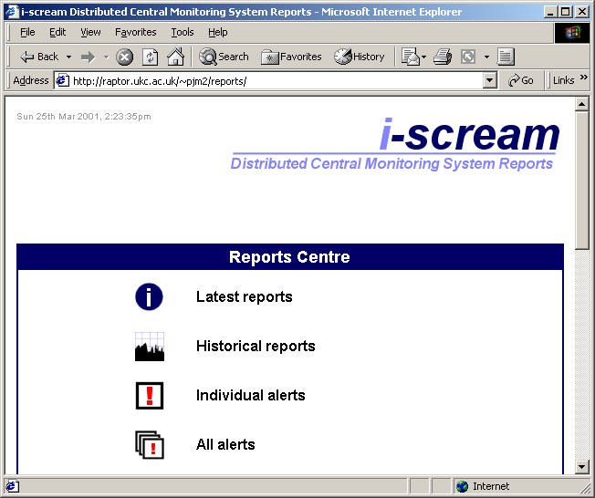

Latest reports
The latest reports page provides you with a list of machines for which reports are available. You may return to the index page by clicking on the large I-scream logo, or by using the “back” button on your web browser.

Latest Reports page.
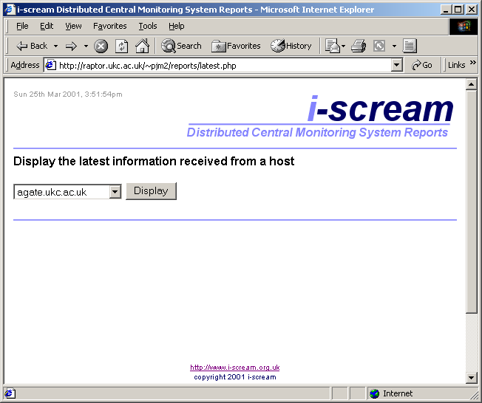

Viewing the latest data received from an individual host
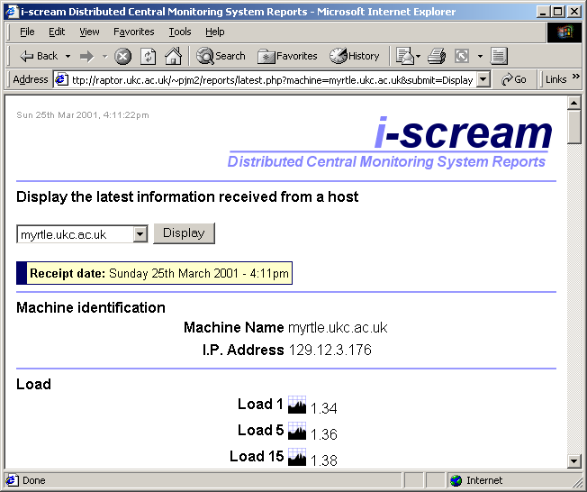

When viewing the latest data received from an individual host, the receipt date is show and a warning is issued if that date is old.

All numerical report values on the page include the small chart logo which links to yesterday’s historical report for the machine.

Viewing the latest data received from an individual host
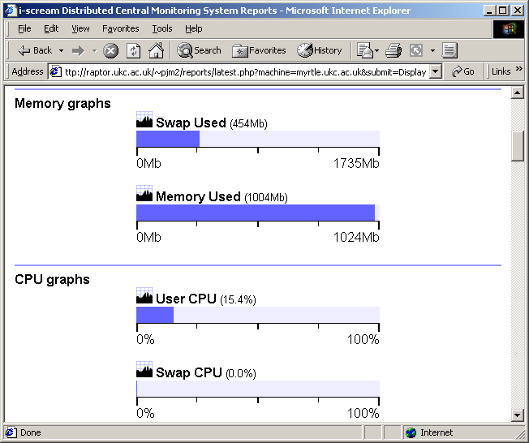

Bar scales are used to represent those values that are better represented graphically, such as memory usage and CPU occupancy.

Historical reports

Historical Reports page
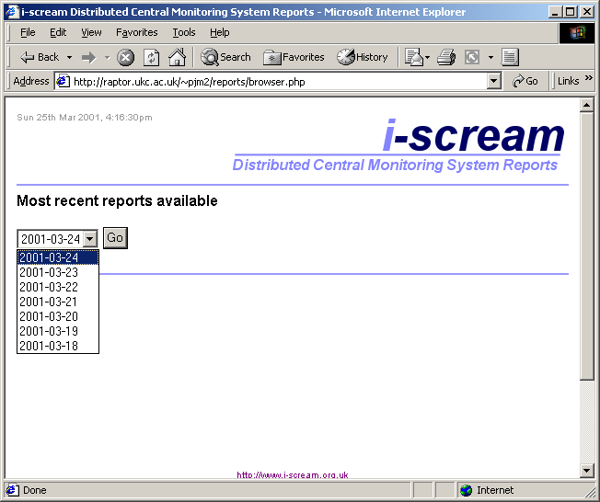

The historical reports page provides a drop-down list of the 7 most recent days for which reports are available. You must select one of these days by clicking on “Go” to see the list of reports that are available.

Historical Reports page
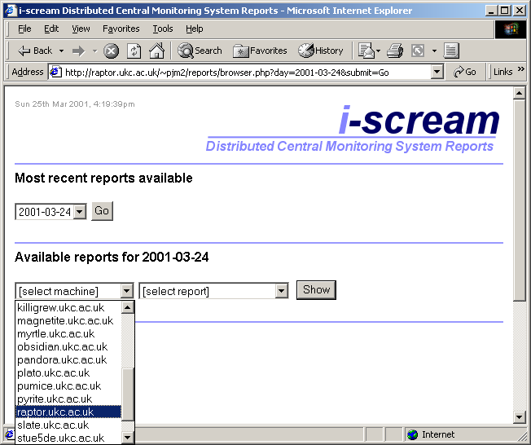

After selecting the day to view reports for, you may select which machine and report to view.
Clicking on the “Show” button will cause the report to be loaded.

Historical Reports page
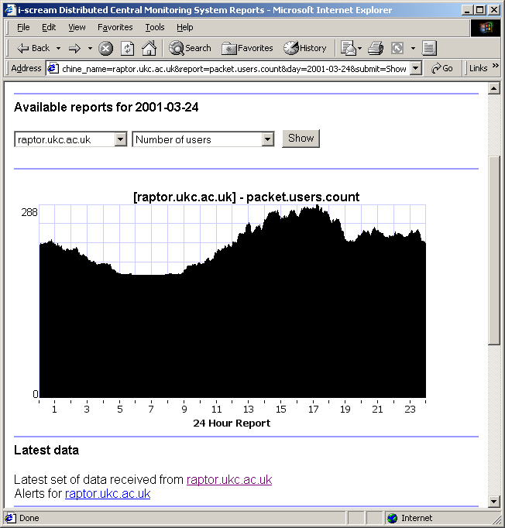

Here is an example of a historical report being viewed. This report shows the number of users on raptor.ukc.ac.uk for a 24-hour time period. The page provides links to the set of latest data received by raptor.ukc.ac.uk and the latest alerts available for the same machine.

Alerts page

The alerts page
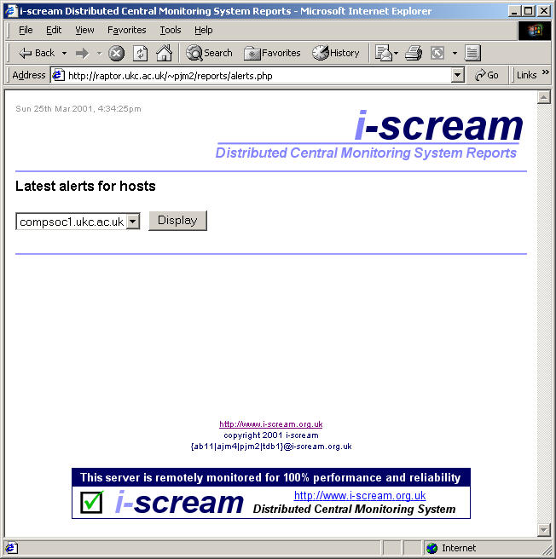

The alerts page displays information provided by the i-scream monitoring system. Alert information is generated by the monitoring system if a host falls outside threshold values set by the server configuration.

Alerts page
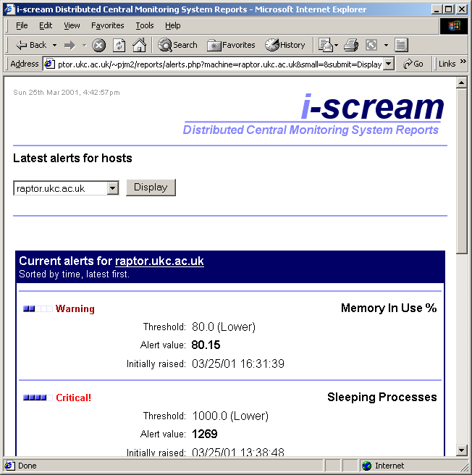

Here is the alert view of a machine called raptor.ukc.ac.uk. Each type of alert appears in the list in time order, with the most recent first.

The small scale to the right of each alert is an indicator of how long the alert has been in place. The monitoring system removes alerts once they have been within acceptable values for long enough.

Each alert shows the threshold value and the value received to raise the alert, along with the date and time that the alert was received.

All reports page
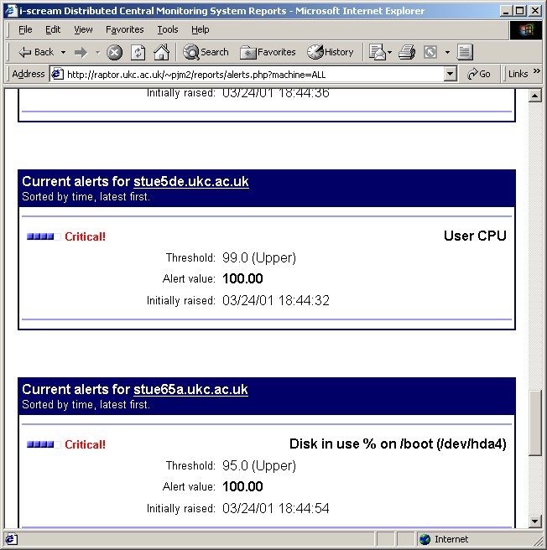

The alerts page can also show a list of all alerts for all machines on the same page. This is useful for quickly skimming over and getting a general idea of the health of all the machines being monitored.

Setting up non-interactive public pages
It is possible to use public.php in order to assist with setting up non-interactive public pages. The key point about such pages is that they can automatically display the latest alert information from the i-scream system without requiring any humnn input. This makes such pages suitable for displaying to the general public, for example, on a helpdesk-style display.

public.php
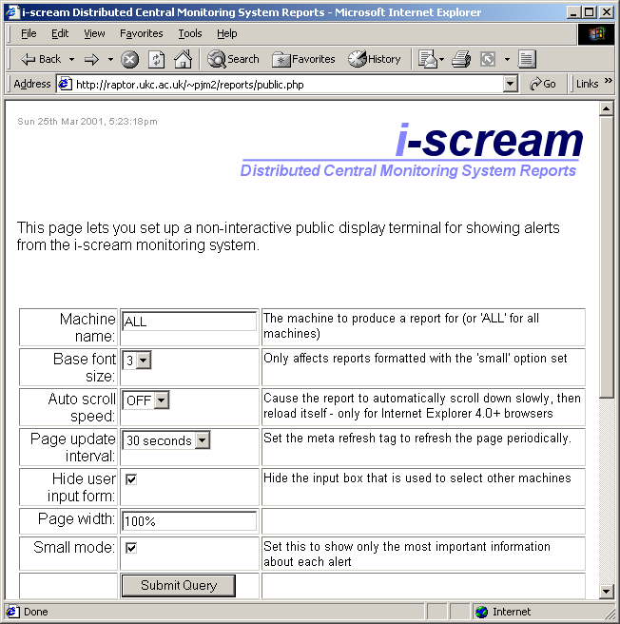

When the above page is submitted, the alerts page will be loaded with the specified settings.

The purpose of each setting is explained on the page itself. The query string itself for the page may be altered manually; in which case, invalid values are ignored and replaced by their default values.

Setting small mode on causes the values and date/time of the alert to be hidden.

Example public alert page
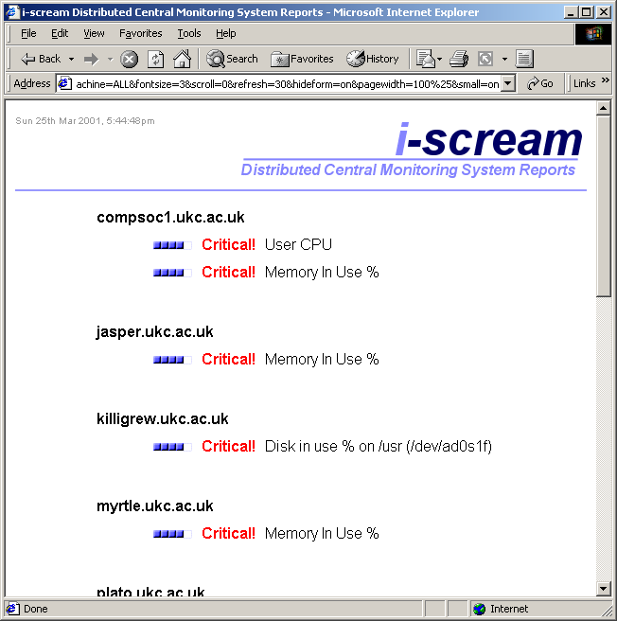

Here is an example of a public display. This page has been created from the example on the previous page and automatically updates the information presented every 30 seconds.

Example public alert page with automatic scrolling
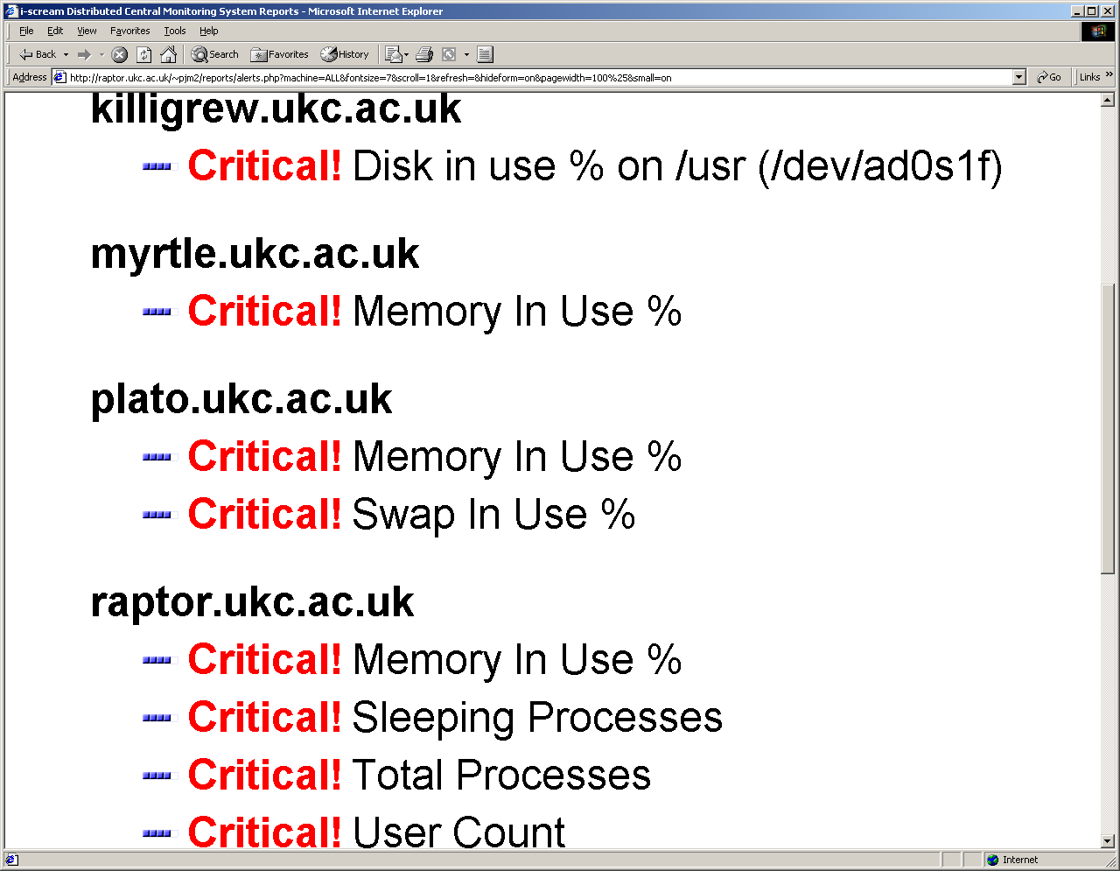

This page has been set up to automatically scroll down at a rate of 1 pixel per 1/20th second. This scrolling feature is only currently supported in Opera browsers, or Microsoft Internet Explorer 4.0+. When the bottom of the page is reached, the page reloads itself.

This is ideal for helpdesk-style displays. The font size has been set to 7, so is easily readable from a distance (even at the high screen resolution shown above) and if you are using Internet Explorer, you can press F11 to turn it into a full-screen display without the grey borders.

The display can be left to run without human intervention.

Further information
Further information is available in our other documentation; the latest versions of which may be found online at the project website. Thank you for using i-scream products.

http://www.i-scream.org.uk

